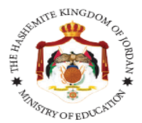

The Ministry of Education
The Education Directorate of Jerash
Al-Haddadah Secondary School
Final Exam- Second Term
Class: 2nd Grade English Language
Time: One hour.
Name: ......................................................................................................................................

1. Look, match and write ( 4 Points )

Cycling - reading - running - playing tennis


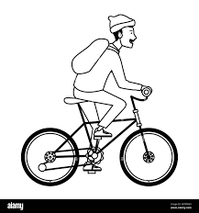

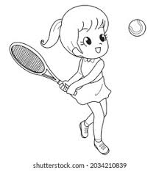

…………………………… ……………………………… ……………………………….. …………………………………

______________________________________________________________

2. Choose the correct answer in the following sentences: (4 points)

1. Is it a ball 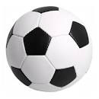?. A-Yes it is b-No it isn't c- No there isn't

2. There-----------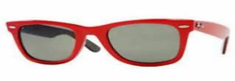 sunglasses. a- is b- are c- ?


3. -------------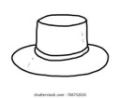 a hat ? a-Is there b- Are there c- Is it

4- Is he go to school? a- yes he is b- N o he isn't

3. count and write: (1 point)

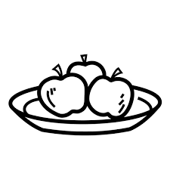

------------------------------------------------------------- ------------------------------------------------------------

4. Spell the following words: (3points)
1. Mazen.--------------------
2- Salem.------------------------

Good Luck
T. Muna AL-Amoor

