The Ministry of Education

Name: ___________ Final exam / First semester Date: / / 2024
Class: 3rd grade
Mark: 16/
___________________________________________________________________________________
Reading:
Question1: read the following text then tick ( ) or cross (X) (2 marks)
Laila: I have tennis lessons at 9 o’clock.
Children: Does Laila do karate at 10 o’clock?
Sami: No, she doesn’t. She skateboards at 10 o’clock.
Children: It's 11 o'clock, where is Laila?
Sami: she roller skates at 11 o'clock.

1) Lila plays tennis at 9 o’clock. ( )
2) Laila skateboards at 11 o’clock. ( )
____________________________________________________________________
Writing: (4 marks)
sk
st
sw
Question2: Write the missing letter:

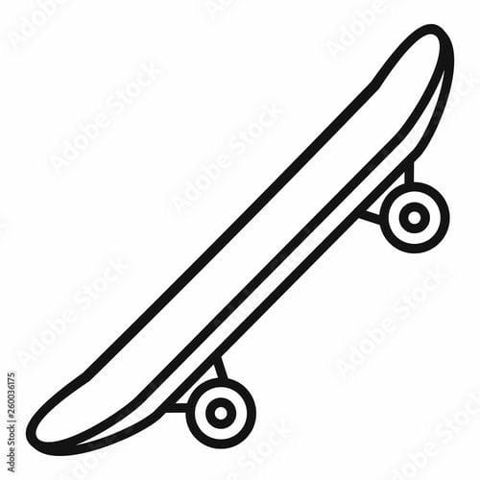 | 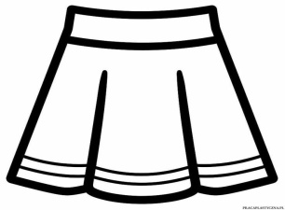 |  | 
_ _ateboard | _ _irt | _ _ar | _ _im

Meanings:
Question3: Match the word with suitable activity: (5 marks)
1)  nurse | 2)  firefighter | 3)  watch TV | 4)  Read books | 5)  Play tennis
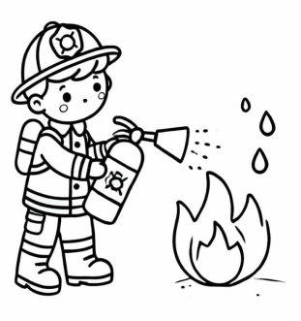 | 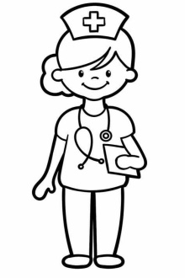 |  | 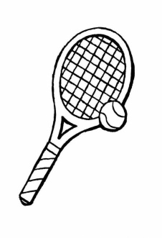 | 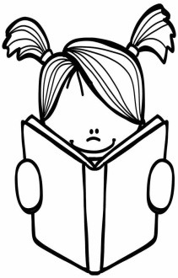

Grammar:
Question4: Circle the correct answer: (5 marks)

plays | play | - He _________ tennis at 10 'oclock.
read | reads | - I___________books.
don’t | doesn’t | - You_______ play tennis at 11 o'clock.
don’t | doesn’t | - Laila ___________ play badminton.
Does | Do | - ______they watch tv in the morning?

