Ministry of Education
Final English exam for the 2nd semester of the academic year 2024/2025 1st grade
Name : ………………………………….. Day: …………………………………….. Date: / / Q1: Match :
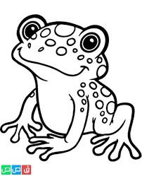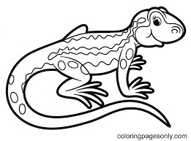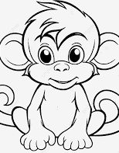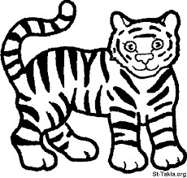

1) Lizard 2) Monkey 3) Frog 4) Tiger
Q2: Write the missing letter : ( K / V / X / Q )
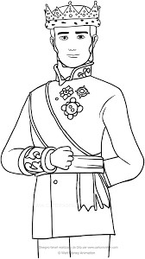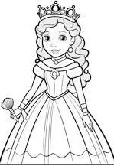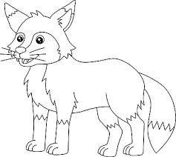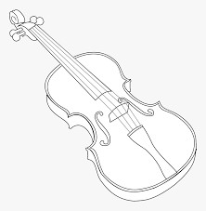

1) ……..ing 2)………ueen 3)……….ox 4)………….iolin

Who’s this ? ( Salah ) / ( Hala ) / ( Bill ) 

Q3: Circle the fruit things : (3)
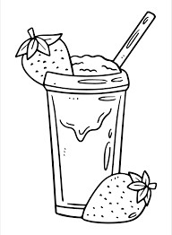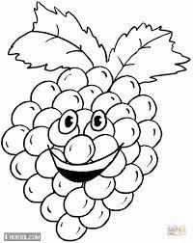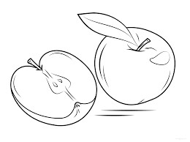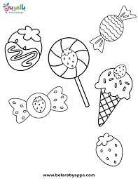

Q4: Write one of these VOWELS : ( A / E / O / U )
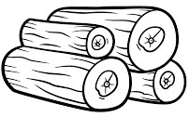
1) B …..s 2) P…….n 3) V…….t 4) L ……..g

Q5: Circle the correct letter :
- Van . ( v / b / m ) 6) Hen ( r / s / h )
- Yes . ( y / o / k ) 7) Zoo ( c / t / z )
- Jug . ( j / h / n ) 8) Kite ( b / d / k )
- Fox . ( X / L / W ) 9) Net ( q / a / n ) 5) On . ( v / u / o ) 10) Up ( u / s / r )
GOOD LUCK

