ورقة العمل رقم (3-1)
The following worksheet is related to the lesson above. How can you highlight concepts and sub-concepts in your teaching through employing it?




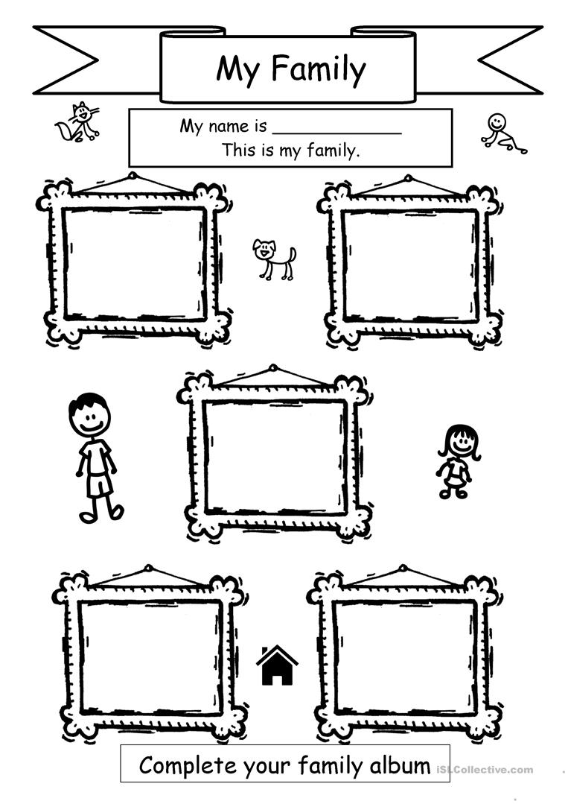
Sarah
This is me
This is my brother
This is my sister
This is my father
This is my mom

