Introduction
Welcome to the The future is in your hands module.
This first unit of the module takes about one hour. By the end of the unit, you'll be able to:
- distinguish between language for plans and language for ambitions
- describe your life plan.
To begin the module, watch the introduction from Rob.

Video Transcript

ROB: Welcome to the module!
This module's title is The future is in your hands. You're going to think about some definite plans you've got for your teaching career, and also any ambitions you may have.
This first unit of the module is about language. You'll listen to a teacher who's talked to a life coach and has a plan more or less mapped out. You'll then analyse the language and try setting your own plan.
You may have done this kind of activity before. I remember during one of my first teaching workshops I was asked to set goals for the following five weeks, five months and then five years. I'm not sure if I kept to them – probably not – but I think the point is to help recognise where you are now and where you want to be, so that you can see what you need to do to get there.

Plans and ambitions 1
Start by thinking back and answering these questions.
- What did you want to be when you were younger?
- What other plans and ambitions did you have?
- Which of these things have since happened in your life?
Now ask yourself these questions and select the Feedback heading for each one to check your answer.
Is a plan something you've decided to do or something you hope to do?
Tabs

Feedback

It's something you've decided to do.
Do you know when it will happen?
Tabs

Feedback

Sometimes you know exactly when it'll happen, but usually you just have a rough idea.
Is an ambition something you've decided to do or something you hope to do?
Tabs

Feedback

An ambition is something you hope to do.
Will an ambition happen?
Tabs

Feedback

It may happen – but you can't be sure.
Do you know when the ambition will happen?
Tabs

Feedback

No, again you can't be sure.

Plans and ambitions 2
Now put the words related to plans and ambitions into the correct category.
Work
- Change jobs
- Teach different grades
- Get a promotion
Interests and hobbies
- Learn a new language
- Travel the world
- Learn how to drive
Family
- Start a family
- Get married

Plans and ambitions 3
Have you ever heard of a 'life coach'?
A life coach is someone you can talk to who helps you decide on your personal plans for the future. Life coaches can help you develop a 'life plan'.
Would you like to receive this kind of coaching? Maybe you would even like to give the coaching! On the next slide you'll listen to Juliana talking about a session with her life coach about her future.

Plans and ambitions 4
Juliana and Nathalie, two friends, are talking about the future. They discuss four topics. As you listen, put the topics in the order that you hear them, with the first one you hear at the top.

00:00lans and ambitions 4
Juliana and Nathalie, two friends, are talking about the future. They discuss four topics. As you listen, put the topics in the order that you hear them, with the first one you hear at the top.
00:00
00:00
Audio transcript
أعلى النموذج
- Family
- Work
- Home
- Interests and hobbies
أسفل النموذج
Transcript
×
NATHALIE: What are you doing, Juliana?
JULIANA: Oh, I’m just drawing out a life plan. I went to see a life coach and he said it was a good idea so that I can think more clearly about what I want to do in the future.
NATHALIE: Can I have a look?
JULIANA: Sure. See here on the left? This is now. So the first thing on my plan is next year. I’m going to move house next year and so I’m going to change jobs too. I mean, I really like the school I’m at now, but I’ll be in a different area and I don’t want to travel too far to work every day.
NATHALIE: Really? I didn’t know you were planning to move?
JULIANA: Yes. We need a bigger place because I’m planning to start a family in the next few years. I wrote that here.
NATHALIE: That’s great!
JULIANA: Yeah. So those are the things I’m sure about. And there are lots of things I’d like to do – I’ve put these as dreams on the right-hand side. I mean I want to learn to drive, but I don’t have the money right now. And also I’d like to learn a new language one day. Maybe Spanish.
NATHALIE: Well, maybe now you’ve written it down on your plan you’ll do it!
JULIANA: Yeah, maybe!
أعلى النموذج
- Family
- Work
- Home
- Interests and hobbies
أسفل النموذج

Language analysis 1
Look at Juliana's life plan. Put the missing words into the correct place. Go back and listen again to check before you submit your answers if you like.
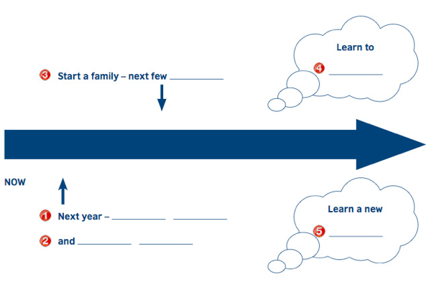

Image description
An image of an arrow going from left to write, from 'now' into the 'future'. There are five sentences or phrases with words missing: 1 Next year… 2 and… 3 Start a family – next few… 4 Learn to… 5 Learn a new...
Next year –
move house

and
change jobs
Start a family – next few
years
Learn to
drive
Learn a new
language

Language analysis 2
What about you? What are your plans and ambitions for the future? Write down some ideas for each of the categories: work, home, family, interests and hobbies. Write in note form – don't use full sentences.

Image description
An image of an arrow going from left to write, from ‘now’ into the 'future'. There are five sentences or phrases with words missing: 1 Next year… 2 and… 3 Start a family – next few… 4 Learn to… 5 Learn a new...
Work
Home
Interests and hobbies
Family
Now draw a life plan using a timeline like Juliana did. Write the year or time if you know when you'll do something. If you don't know, you can use a thought bubble, like in Juliana's example.

Language analysis 3
Here are some things that Juliana said.
- I want to learn to drive but I don't have the money right now.
- I'm going to move house next year.
- I'd like to learn a new language one day.
- We're planning to start a family in the next few years.
Now look at these questions and think about your answers. Make a note of your answers if you like. Open the Feedback heading to check them.
- In which two sentences above does Juliana describe her plans? Which words show that these are plans?
- In the other two sentences, Juliana describes her dreams and ambitions. Which words show this?
- Look at the structure of the sentences. What do they have in common?
- Do you know what to call the verb forms in bold?
- What word is shortened to 'd in sentence c?
Tabs

Feedback

- b and d. You know this from the time references – next year and in the next few years. The grammar also shows us: going to and planning to are used to talk about plans – something you're certain of.
- one day and I don't have the money right now. Also, want to and would like to don't suggest a certain plan.
- They all have to followed by a verb.
- You may know this as the infinitive, the bare infinitive, the infinitive without to, the base form or verb 1.
- would.

Language analysis 4
Use the words here to complete the language summary.
Describing plans
I'm|I am
going to + infinitive verb
I'm
planning to
+ infinitive verb
Describing ambitions or dreams
I'd
like to
+ infinitive verb

I
want to + infinitive verb

Making a plan 1
In this section you'll talk through your own plan, using the language you've just looked at. Watch Rob introduce the task.

Video Transcript

ROB: In this section you're going to need something to record yourself, such as a mobile phone, as you'll do a speaking task that you'll then need to listen to. You'll need to look back at notes you made in the previous section and your plan.
It's a good idea, when you're doing tasks like these, to first have a think about what you'll say. You can then make some notes if you want to, but try to read as little as possible, so that when you're listening you can hear your speaking skills, rather than your reading aloud skills. If there's someone else with you, then you might prefer to speak to them and record that.

Making a plan 2
Look at the ideas for a future career below. Select the ones you'd like to do. Then record yourself saying a bit more about your plans or ambitions. Use 'I'm going to...' or 'I'm planning to...' to describe your plans. Use 'I want to...' or 'I'd like to...' to describe your dreams and ambitions. Take time to do this properly!
Earn more money
Get another teaching qualification
Teach a different subject
Become a supervisor/co-ordinator/headteacher
Become a teacher trainer
Teach older/younger children
Change schools
Publish articles about teaching
Making a plan 3
Read the pairs of sentences and for each pair decide which one's correct. Think about why the other one isn't correct.
Which one's correct?
I'm planning to start my own business in the next few years.
I'm planning start my own business in the next few years.
Feedback
A is correct. B is missing 'to'.
أعلى النموذج
أسفل النموذج

Making a plan 3
Read the pairs of sentences and for each pair decide which one's correct. Think about why the other one isn't correct.
Which one's correct?
I really like to visit Australia one day.
I'd really like to visit Australia one day.
Feedback
B is correct. A is missing 'd'.
أعلى النموذج
أسفل النموذج

Making a plan 3
Read the pairs of sentences and for each pair decide which one's correct. Think about why the other one isn't correct.
Which one's correct?
We're going to move house.
We're go to move house.
Feedback
A is correct. B has the wrong form of 'go'.
أعلى النموذج
أسفل النموذج

Making a plan 4
The next three sentences have grammar mistakes. Write the whole sentence correctly. Use contractions if possible, and be careful with your spelling and punctuation.
I'm not want to change jobs.
I don't want to change jobs.
I'm going looking for a good Arabic teacher.
I'm going to look for a good Arabic teacher.
She want to get a better job.
She wants to get a better job.

Making a plan 5
To finish this section, listen to the recording you made. Did you make any of the mistakes you just corrected? Perhaps you've seen some other language you'd like to include in yours now.
Make a new recording and focus on these things:
1. The difference between describing plans and ambitions
Describing plans:
I'm going to...
I'm planning to...
Describing ambitions or dreams:
I'd like to…
I want to...
2. Using time references
Describing plans: next year/in a few years/in five years, etc.
Describing ambitions or dreams: one day/someday/at some point

End of unit
That's the end of Unit 1. You should now be able to:
- distinguish between language for plans and language for ambitions
- describe your life plan.
Watch Rob's round-up.

Video Transcript

ROB: That's it for this first unit of the module. You've thought a lot about the language for describing plans and ambitions, and should now be more confident talking about your own life plan.
How did you get on with the speaking task? Did you find it useful to listen to your own language, and to focus on specific points? If you did, perhaps your learners would too. Pair work and group work is most often used for speaking practice, but asking learners to record themselves and listen back can also be really beneficial, especially when it's done often so learners aren't shy listening to their own voices!
The next unit of this module has a pronunciation focus, so you might like to keep your recordings and listen later for the pronunciation you used. See you there!
Introduction
Welcome to the second unit of the The future is in your hands module.
This unit takes about one hour. By the end of the unit, you'll be able to:
- recognise weak forms in connected speech
- recognise contractions in connected speech.
To begin the unit, watch the introduction from Rob.

Video Transcript

ROB: This unit's all about pronunciation. You're going to listen to some very small bits of language to hear the weak or unstressed words in language about future plans and ambitions.
Make sure you try saying all the words out loud and keep your voice recorder nearby. One of the best ways to check you're producing the different sounds is to simply record and then listen.
Later in the module, you'll look at a game you can use in the classroom on the same topic. But to start the unit, you'll do a short dictation. You already know the focus of this unit, so make sure you listen out for the unstressed words. When you're ready, move on to the next slide to start your dictation.

Unstressed sounds 1
Listen and write the six sentences. Pause the clip after each sentence. The teachers speak quite quickly, but you can listen as many times as you need to. Use contractions where possible, and be careful with your spelling and punctuation!
1. I want to get a promotion.
2. We're planning to travel the world.
3. I'm going to go for a walk.
4. I don't want to change jobs.
5. She's planning to start a family.
6. I'd like to move house.
Unstressed sounds 2
Did you find this easy or difficult? If you found it to be difficult, don't worry. Some sounds can be difficult to hear in spoken English because they aren't stressed or because they're joined together. Look at these examples.
get a sounds like 'gettuh'
for a sounds like 'furuh'
start a sounds like 'startuh'
You'll look at this further in the next exercise. First, listen again to all six sentences and repeat them out loud. You may need to pause to do this.
Tabs

Audio transcript

- I want to get a promotion.
- We're planning to travel the world.
- I'm going to go for a walk.
- I don't want to change jobs.
- She's planning to start a family.
- I'd like to move house.
00:00
00:00

Unstressed sounds 3
Listen again to the first four sentences and select the words that are unstressed.
I want to get a promotion

Unstressed sounds 3
Listen again to the first four sentences and select the words that are unstressed.
We're planning to travel the world

Unstressed sounds 3
Listen again to the first four sentences and select the words that are unstressed.
I'm going to go for a walk

Unstressed sounds 3
Listen again to the first four sentences and select the words that are unstressed.
I don't want to change jobs

Unstressed sounds 4
Say these words out loud:
to | for | a
When you say the words in isolation, you normally use the stressed form, e.g. /tu:/ for to. However, in connected speech, it's common for these words to be unstressed, as you saw on the previous slide.
The activity was designed to raise awareness of how pronunciation of these words can change when they're in the middle of a sentence.
The three words highlighted on this slide all usually have the same sound when they're unstressed in the middle of sentences: /ə/ (known as the 'schwa').
Practise saying the different forms (stressed and unstressed) of each word. Record yourself and listen to the difference.

Contractions 1
Look at this sentence from the recording:
She's planning to start a family.
Where's the contraction? Watch Rob talk about contractions and why they're important.

Video Transcript

ROB: You probably already know quite a bit about contractions, and when they're used in English. In the sentence, the contraction is she's, and the full form of course is she is.
It's important to spend some time on this, and it's not just the words that change slightly, but also the pronunciation. Compare:
She is planning to start a family.
She’s planning to start a family.
She is
She's
This is why learners often find it difficult following natural speech; they might know the language, but when it's spoken and the speaker modifies it, it can be hard to hear all the words.
The next few activities will help you to hear as well as produce the different sounds.

Contractions 2
Look at the other sentences from the recording, then match the contraction with the full word.
We're planning to travel the world.
- are
I'm going to go for a walk.
- am
I don't want to change jobs.
- not
I'd like to move house.
- would

Contractions 3
Listen to the words in full sentences and match them with the contractions. When you're finished, listen and repeat.
A: If he gets a new job, he'll buy a car.
B: She told me she's planning to buy a new house.
C: He'd like to earn more money.
D: They'll go home early on Friday.
E: Tomorrow they're going on holiday.
F: Next week he's going to work in a new school.
G: They'd like to develop their teaching.
H: If she gets a new job, she'll buy a car.
Audio transcript
she's
- Toggle AudioB
they're
- Toggle AudioE
he'll
- Toggle AudioA
they'd
- Toggle AudioG
he'd
- Toggle AudioC
she'll
- Toggle AudioH
he's
- Toggle AudioF
they'll
- Toggle AudioD

Contractions 4
Look at the resource for a pronunciation game called 'Which contraction?' now. Put the instructions to the game into the correct order.
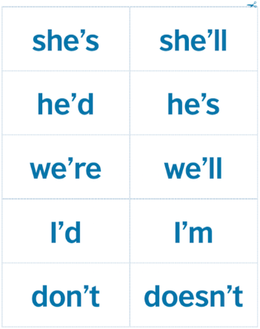
An image of a piece of paper divided into 10 parts. Each part has a word in it: she's, she'll, he'd, he's, we're, we'll, I'd, I'm, don't, doesn't.
أعلى النموذج
- Divide learners into pairs.
- Hand out a set of cut-up pieces of paper to each pair.
- First tell learners to say the words on the cards to each other. Monitor and ensure they're pronouncing the contractions correctly.
- After they've done that, tell learners to listen, and when they hear a contraction they should hold up the correct card.
- Read some questions (that you prepared earlier) with contractions in them.
- Participants hold up the cards with the contraction they hear.
- Confirm correct answers each time.
- Ask participants to discuss the question together.
أسفل النموذج

Contractions 5
Do you think you could use the game you read about on the previous slide with your learners? Would you need to adapt it at all? Read how two teachers would adapt it slightly and decide if they have higher- or lower-level learners.
I'd ask my learners to write their own sentences and read them out to their partner or group, who identify the sound.
Lower level
Higher level
أعلى النموذج
أسفل النموذج
I'd just start with two of the contractions. I'd ask learners to do an action for each one, for example 'Stand up if you hear I'll' and 'Clap if you hear I'd.'
Lower level
Higher level
أعلى النموذج
أسفل النموذج

End of unit
That’s the end of Unit 2. You should now be able to
- recognise weak forms in connected speech
- recognise contractions in connected speech.
Watch Rob’s round-up.

Video Transcript

ROB: So, do you think the pronunciation game could work with your learners? Lots of teachers say they find teaching pronunciation scary and I think I felt the same at one point, but it doesn't need to be. The main thing is to give your learners, and yourself, lots and lots of practice. This includes practice of very small sounds that change words, like you’ve looked at here, as well as giving freer speaking practice where learners have opportunities to actually use them.
OK, in the next unit you'll return to the main language focus of future plans and ambitions, this time within the context of teaching them as functions.

Introduction
Welcome to the third unit of the The future is in your hands module.
This unit takes about one hour. By the end of the unit, you'll be able to:
- teach functions in a context
- talk about using a communicative activity (Names in a hat) in your context.
To begin the unit, watch the introduction from Rob.

Video Transcript

ROB: Hi, and welcome to this, the final unit of the module.
In the first unit you focused on the language of plans for the future and ambitions. In the second you looked at the pronunciation focus of unstressed words and contractions. In this unit you're going to focus on looking at the same language as a function, and how to teach that communicatively in your classes.
First, you'll look at a lesson where the teacher gets the learners to talk about their plans for the weekend. Later you'll look at a communicative activity that you may be able to use in your context.
I hope you'll enjoy the unit!

Teaching functions 1
Look at the picture story which shows a teacher giving a grammar lesson. Put the stages into the correct order.
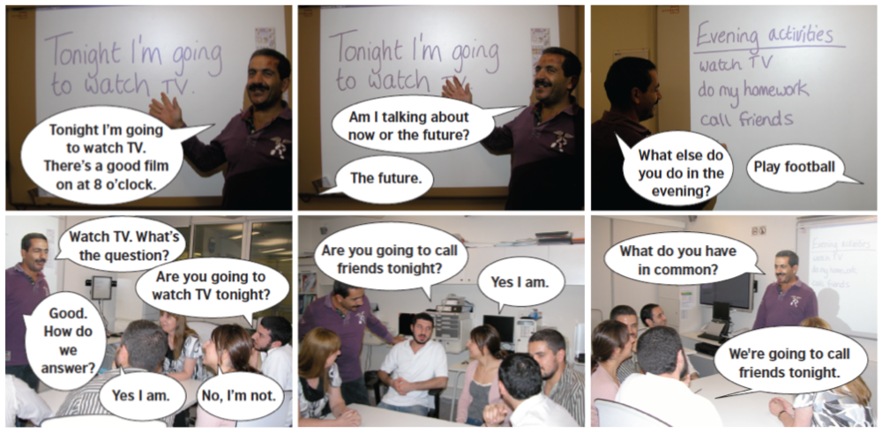

Image description
Picture 1.
Teacher: 'Tonight I'm going to watch TV. There's a good film on at 8 o'clock.'.
Picture 2.
Teacher: 'Am I talking about now or the future?'
Learner: 'The future.'
Picture 3.
Teacher: 'What else do you do in the evening?'.
Learner: 'Play football.'
Picture 4.
Teacher: 'Watch TV. What's the question?'
Learner 1: 'Are you going to watch TV tonight?'
Teacher: 'Good. How do we answer?'
Learner 2: 'Yes I am.'
Learner 3: 'No I'm not.'
Picture 5.
Learner 1: 'Are you going to call friends tonight?'
Learner 2: 'Yes I am.'
Picture 6.
Teacher: 'What do you have in common?'
Learner 1: 'We're going to call friends tonight.'
أعلى النموذج
- The teacher introduces the language with an example.
- The teacher asks concept questions to check understanding.
- The teacher elicits vocabulary for the practice activity.
- The teacher elicits questions and answers for the practice activity.
- Learners ask and answer questions in pairs and small groups to practise the language.
- The teacher elicits ideas from the class.
أسفل النموذج

Teaching functions 2
Think again about the lesson you read on the previous slide. Match each question with the correct answer.
What's the grammar focus of this lesson?
- Future form – going to
What situation does the teacher use to introduce the language?
- Talking about plans for tonight
What example does he use?
- I'm going to watch TV tonight. (picture 1)
How does he check that the learners have understood?
- He asks concept questions. (picture 2)
How do the learners practise the language?
- They ask each other about their plans for tonight. (picture 3)

Teaching functions 3
Look at the definitions of words connected with lesson planning.
Complete the teacher's lesson plan with the correct words.
Context | The situation when you use specific grammar or vocabulary.
Concept questions | Questions a teacher asks to check if learners understand.
Language focus | The grammar or vocabulary you want to teach in a lesson.
Function | What you use the language for.
Language practice | Activities for learners to practise the language.
Example | A sentence that shows how you use the language.

أعلى النموذج

- Function
Talking about plans
- Language focus
Going to
- Context
Finding things in common – comparing evening activities with a friend
- Example
I'm going to watch TV tonight.
أسفل النموذج

أعلى النموذج
- Concept questions
Am I talking about now or the future? (the future)
When in the future? (tonight)
Is this my plan or just an idea? (my plan)
Are you going to watch TV tonight?
What are you going to watch? (Elicit one or two examples.)
Elicit the short answers ('Yes, I am' / 'No, I'm not')
أسفل النموذج

أعلى النموذج
- Language practice
a. Teacher elicits ten common evening activities from the class, writes them on the board.
b. Learners work in pairs to find things they have in common. They ask: 'Are you going to… tonight?'
c. Elicit from one or two pairs things they have in common.
أسفل النموذج

Teaching functions 4
In the lesson, the teacher is focusing on the function of the language (what it's used for), not just the language as a piece of grammar. This can be very useful for learners because they can clearly see where they can use the language in real life.
How do you make sure your learners see the connection between their lessons and real life? As a learner, how do you make sure you have opportunities to see the language you’re focusing on in real-life contexts?

Teaching functions 5
What did you think of the lesson? Read the questions and think about your answers, then select Feedback to see some suggestions.
- How does the context help learners?
- Why is it a good idea to think of examples before the class?
- How do concept questions help the learners? How do they help the teacher?
Tabs

Feedback

- A context shows learners how the language is useful in a particular situation in their lives. It also helps them understand the meaning from how the language is used.
- Thinking of concept questions before the class means you’re prepared and don’t have to think of them ‘on the spot’ in class. Also, you can check they’re clear examples of the functions you want to teach. It can help you to think about problems learners might have with the language and how you can help them.
- They make learners think about meaning and test their understanding. They help teachers to check if their learners understand the language or not. Remember that ‘Do you understand?’ is not an effective concept question (learners might say ‘yes’ and you don’t know if they understand or not!).
How can you use these ideas in your lesson planning?

Teaching functions 6
What did you think of the lesson? Could you use a similar lesson plan in your class? Watch as Rob talks a bit more about it.

Video Transcript

ROB: The lesson you've looked at in this unit focused on the function – that is, talking about plans for the future – rather than the language focus of going to.
Of course, the language point probably came up, but the learners were probably more focused on getting their meaning across.
Practising language communicatively like this helps learners to personalise and remember the language, and it gives them the opportunity to practise new language in a real-life context.
It's important for you as a learner, too, to make sure you have real-life opportunities for using the language you're studying. Have a think about how you can practise language for plans. This could be by finding a way you can actually make some real plans in English, and of course you'll also come across most language points at some point if you regularly read the news.
Another way is by teaching it in your own classes. In the next section you'll look at a game called 'Names in a hat', which does just that.

Names in a hat 1
You're now going to look at an activity called 'Names in a hat'. Add the correct verb to each instruction and then read through all the stages.
أعلى النموذج
- Hand out
two or three pieces of paper to learners.
أسفل النموذج
أعلى النموذج
- Tell
learners to write a true sentence about their plans for the weekend on each piece of paper. If they have two pieces of paper they should write two different sentences, one on each.
أسفل النموذج
أعلى النموذج
- Collect
the sentences from learners and put them in a bag or box (the 'hat').
أسفل النموذج
أعلى النموذج
- Demonstrate
by taking a sentence from the hat and eliciting the question learners need to ask to find out who wrote it.
أسفل النموذج
أعلى النموذج
Each learner
- takes
one sentence from the hat. They move around the room, asking questions to find out who wrote it. Listen and make notes of common errors.
أسفل النموذج
أعلى النموذج
When they find who wrote the sentence, they can take another from the bag and
- repeat
the last stage.
أسفل النموذج
أعلى النموذج
- Continue
until all sentences have been used or learners have had enough practice.
أسفل النموذج
أعلى النموذج
- Write
common errors that you noted down on the board and elicit corrections.
أسفل النموذج

Names in a hat 2
Imagine one of the pieces of paper from the 'Names in a hat' activity says this: 'At the weekend I'm going to have a party.'
Rearrange the words to make questions to discover who wrote it.
- Are
- you
- going
- to
- have
- a
- party?

Names in a hat 2
Imagine one of the pieces of paper from the 'Names in a hat' activity says this: 'At the weekend I'm going to have a party.'
Rearrange the words to make questions to discover who wrote it.
- Are
- you
- planning
- to
- have
- a
- party?

Names in a hat 3
Could you use 'Names in a hat' with your learners?
The activity is adaptable for almost all language points and is fun for learners as they can practise language in a communicative way to solve a 'puzzle' (who wrote what).
It helps learners to practise new language in a controlled way. Because they have to repeat the language several times, it helps memorisation and pronunciation. It also gives you, as the teacher, the opportunity to monitor how they're doing and to give focused fe

End of module
That's the end of Unit 3. You should now be able to:
- teach functions in a context
- talk about using a communicative activity (Names in a hat) in your context.
Watch Rob's round-up.

Video Transcript

ROB: That's the end of this unit and The future is in your hands module. Hopefully you'll now feel more confident using language for making plans and talking about your ambitions, and also have some new ideas for your classes.
See you in the next module!

