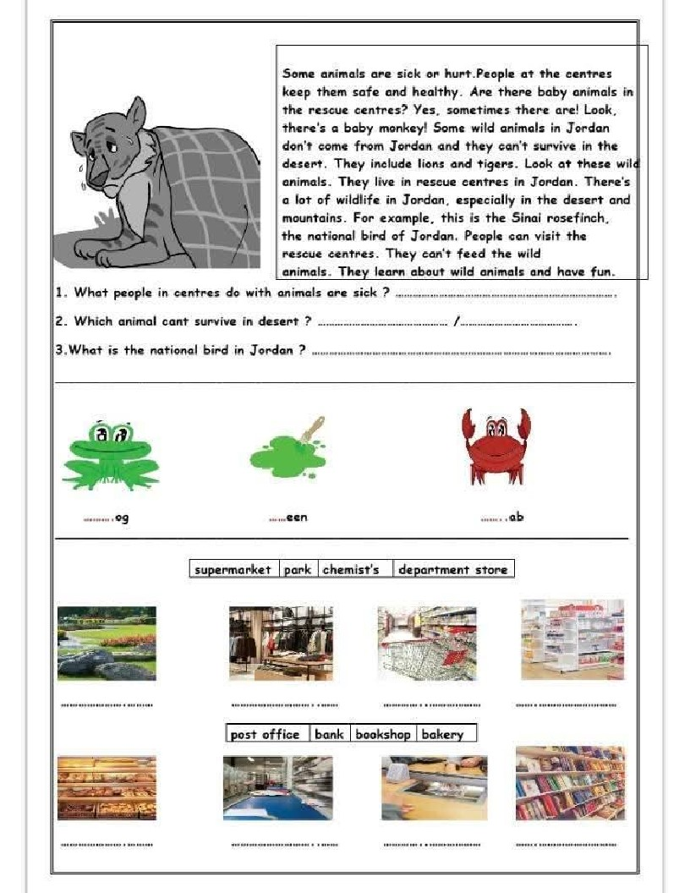
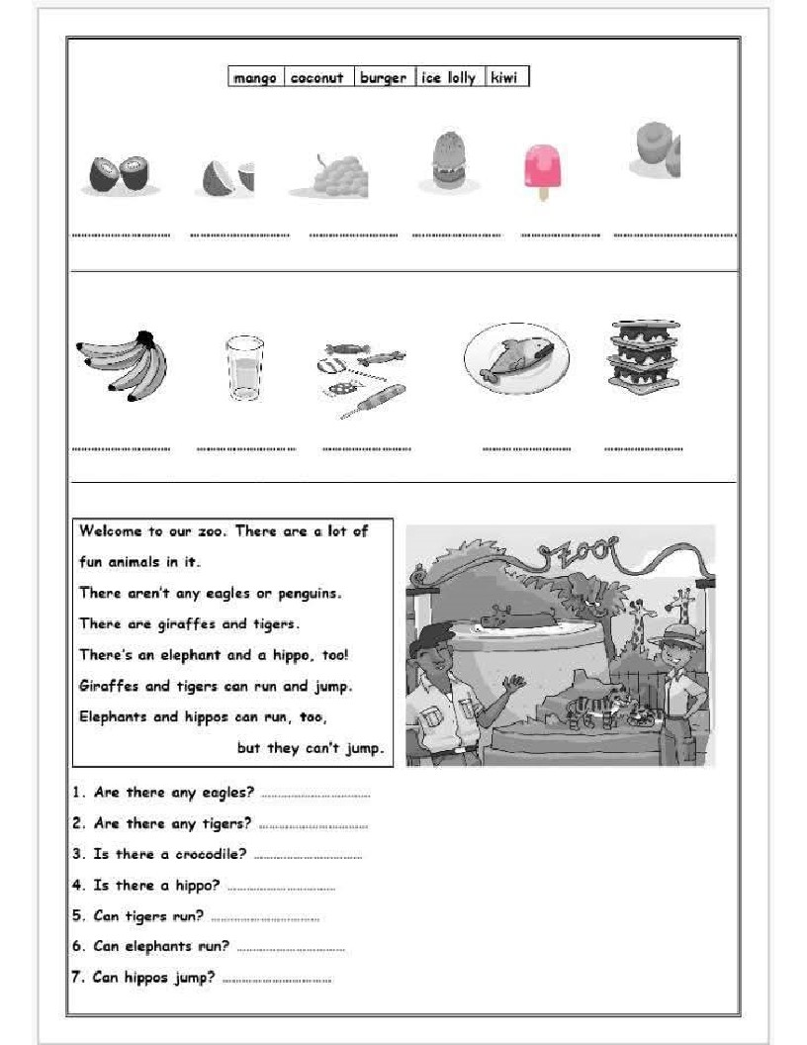

LisTen and cipcle fwo wopds wiTh tha дате sound.
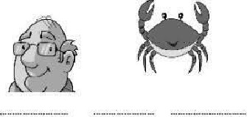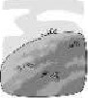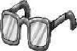
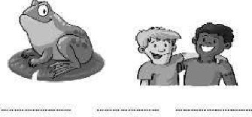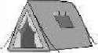
Отел and wr•tt• fr. от ср.
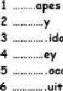. .oeodi[•
iday
eIeph"f$  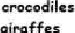 | 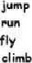  swim

евеопиТ |  | kiwi |  |  | Гее [о
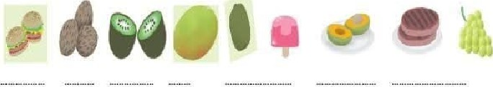

E” i, Exam / Grade 3
Section .
Leek ( 8 p
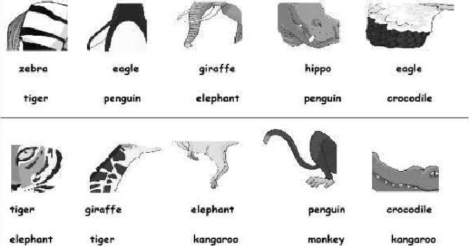
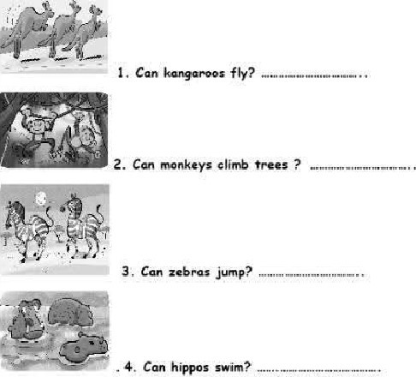
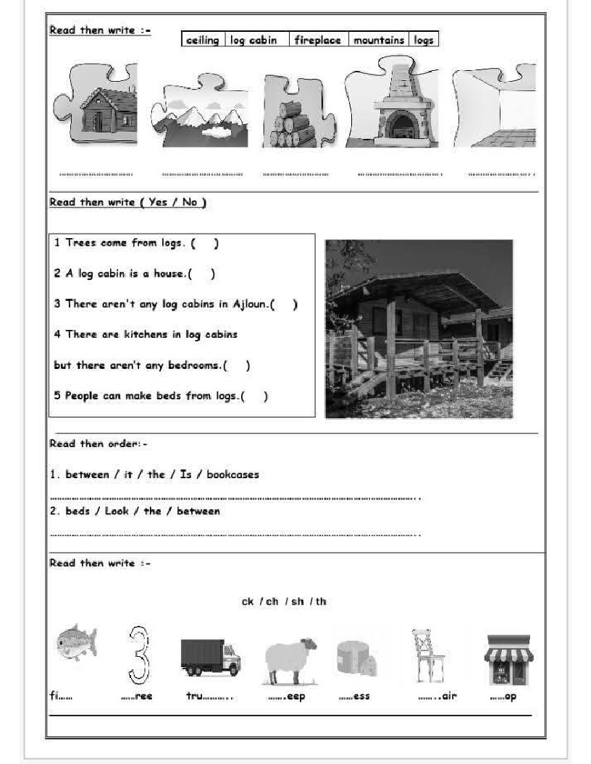
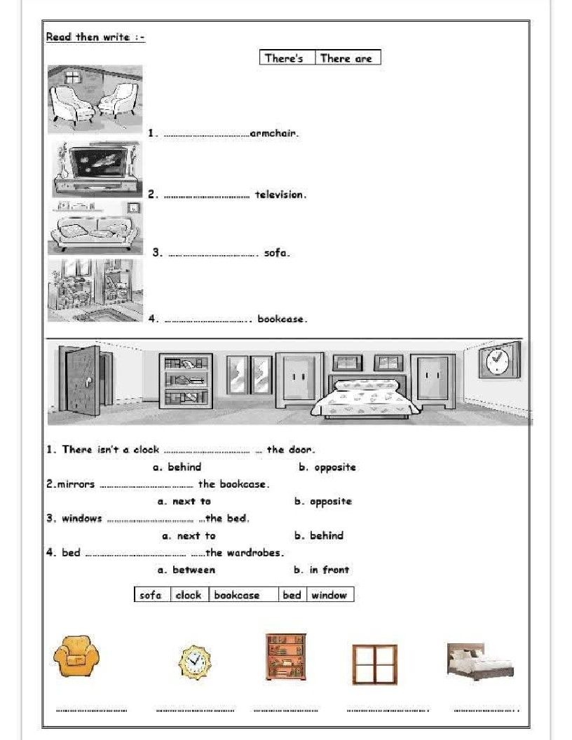
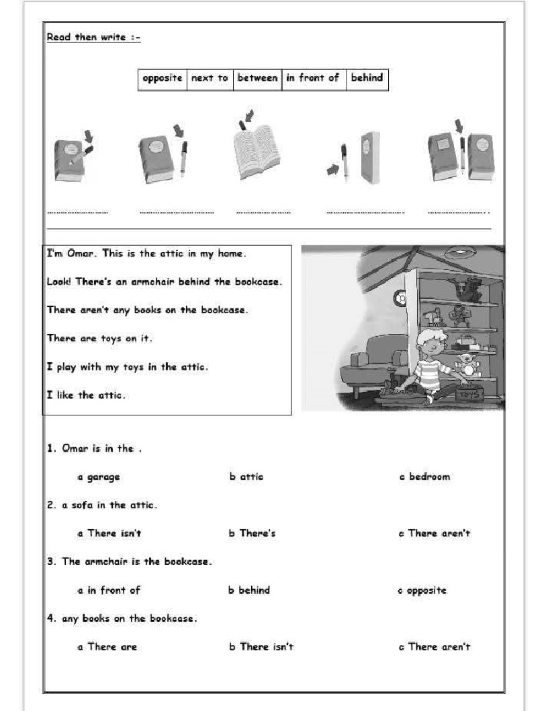

F S , " 2024 / 2025 E |i E / Grade
5,, on -
kead then * ,
televisiøn | 罒rr |  |  | wardrobe日
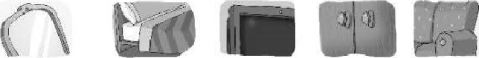
do | ,r吖•0 |  | bookcase |  | * | 0,k
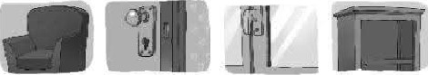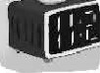
ad | ," * , :一( Yes No |  |  | 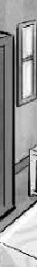 |  |  |  |  |  |  | 
There's 0 bed-( )
生Theres adoor ( )
5· There's 0 b00 ”,. (
 |  |  |  |  |  |  |  |  |  |  | 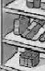
 |  |  |  |  |  |  |  |  | 
 |  |  | 

