Class:- Second grade Seco
Class: 2nd Grade Second Semester
Second Exam
Name: -------------------------------. School: ----------------------------------

2. Write the time (5 pints)

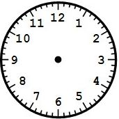
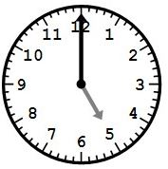
1. Draw hands of the clock

_________________________________________________________________________________________________________________________________________________________________________________________________________________________________________________________________________________________________________________________________________________________________________________________________________________________________________________

It's nine o'clock it’s half past two

2. Count:- (6 pints)

Seven four eleven twenty- one

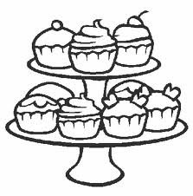
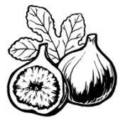
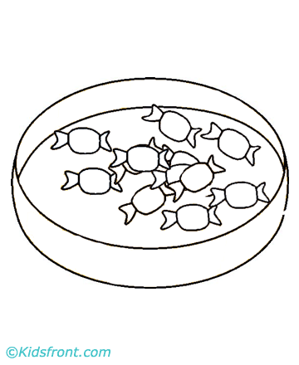

1. How many figs are there? There are ___________________________
2. How many sweets are there? There are ________________________
3. How many cakes are there? There are _________________________
____________________________________________________________________________

3. What does she look like?(8marks)

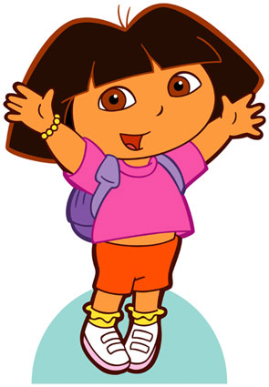

She's _______________.

She's got _____________ _____________ hair

and ___________ eyes.

Long/ short


4. Read and colour :-(6points)
1- He is got black hair and blue eyes.

2- He is got grey hair and brown eyes.

3- He is got yellow hair and green eyes.

THE END
WITH MY BEST WISHES
TEACHER:-

