
Student‘s Name:------------------------------
Section:-------------------
Date:-----------------
20
School:……………………………..
First English Exam
Scholastic year:2022/2023

Grade:3rd Grade
answer with ( ) or ( )
1-Mazen and Asma go to their school at half past six ( )

2-Mazen’s favourite day is Friday ( )

3-He doesn’t like Maths ( )

4-Mazen and Asma leave school at one o’clock ( )

5-They don’t have lunch with their family ( )

________________________________________
3-Does Kareem Like Playing hand ball?
_________________________________________
4-What does Samira Sometimes Play?
_____________________________________________________

2

Mazen and Asma’ are brothers. They go to their school at half past seven . Mazen’s favourite day is Thursday because he has Maths and he likes it very much. They leave school at one o’clock. At quarter past two they have lunch with their family.

Question one:- ( /5)
Read the following paragraph then answer the questions :
Photos Wardrobe timetable fridge pencil case
( /5)
Question Two:-
Complete the sentences using wods in the box:


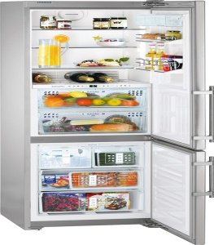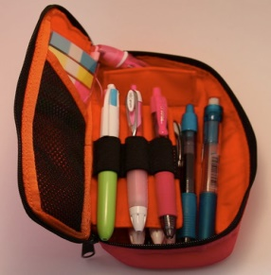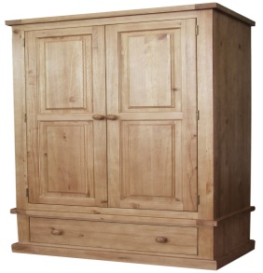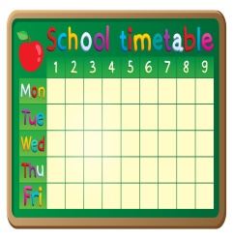
_______________ ________________ __________________ ________________ _____________
Question three:-
Circle the correct answer:
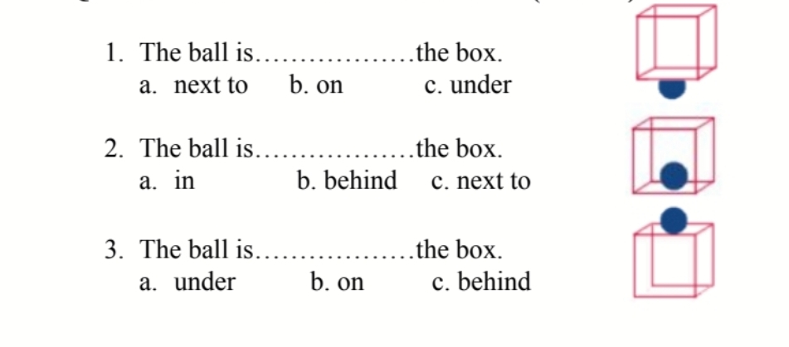

( /3)

( /4)
Question four :- Match
What time is it :

- It’s three o’clock

- It’s quarter to six

- It’s quarter past one

- It’s half past ten

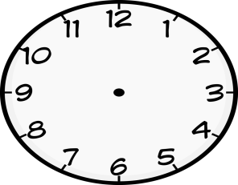

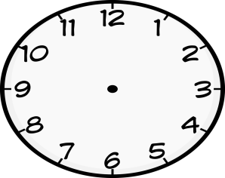
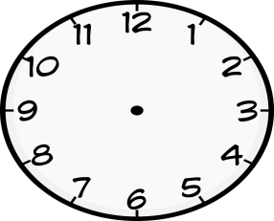
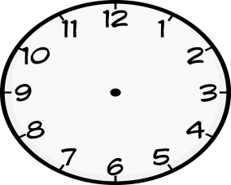
_ 
Sara omar

Answer:
1-Whose flower is this?____________________
2-Whose cars are these?_____________________
( /3)
Question 5

تم التحميل من احباب الأردن التعليمي
www.jo1jo.com

